Last updated 20 September 07. The latest version of this document can always be found at www.enjolrasworld.com. See last page for legal & © information.
Additions? Corrections? Contact Richard J. Arndt: rarndt39@hotmail.com.

The Unconventional ComiCon Costumer

A 2007 Interview with Angelique Trouvere!
By Richard Arndt

RA: We’re welcoming Angelique Trouvere, model and costumer of Warren, DC & Marvel characters. Angelique, can you tell us a little of your background?

AT: I’m originally from New York. I studied Fashion Art, Design & Construction in a school that specialized in the fashion trade because I had artistic talent and liked designing clothes.

In my senior year I suspected that there might be a problem or, perhaps, a hint of things to come because I was constantly hearing things like…”That’s very nice but a little too costumey”. By the way, my bestest friend, Animal, who is an amazing costumer, was turned down for the same reason when she tried out for Bravo’s “Project Runway”. So it’s not just me

Anyway, I wanted to work in the costume field but that was easier said than done. I did, however, spend a lot of time working in theatres and learning my craft on my own. I worked as a dancer and, because I was interested in astrology, I called myself Destiny. Dancing was a great job for me in that it gave me confidence, poise and grace as well as the time and money to work on costumes and show them too.

In fact, that’s how I found out about Vampirella. I remember one day I was at a theatre when I noticed a coworker reading a magazine-sized comic book and I asked if I could see it. It was a Vampirella and I was instantly hooked. I guess it was love at first bite? There was an ad in the book that told of a ComicArt Convention that was happening in the near future. That was Phil Seuling’s ComicArt Con of 1972 and that’s where it all began.

RA: The first time I heard of you was the Gerry Boudreau article that ran in the back of most of the Warren Magazines in 1973. Was that your first con appearance?
AT: Actually, my first convention was Phil Seuling's ComicArt convention which was held over the July 4th weekend in 1972 but I only went for one day, just to check out the dealer's room—I wanted to find more Vampirella comics and had no idea there even was a masquerade.
I met some really wonderful people at this first con. They were fans and dealers and they told me about the masquerade, which I had just missed, and suggested that I should enter the next year’s since I was interest in costume making.
So a year later, my friends and I showed up at the 1973 Seuling's July ComicArt Con masquerade. I was dressed as Vampirella. As a budding costumer back then, Vampi was—or rather HAD to be—my first costume for competition.
I loved Vampirella--she was everything that I aspired to be: brave, strong, a true champion, beautiful, tall....
By the way, many costuming fan-girls had a Vampirella costume in their collections—it was the gold standard of costuming back then. In fact my friend, Kathy Bushman, recreated by hand the very first Vampirella costume two months after the Vampirella magazine premiered, entering it in the 1969 WorldCon masquerade in St. Louis, Missouri, where she landed an Honorable Mention for her efforts.
Anyway, as we wandered into the area where the masquerade entrants awaited the start of the show, my friends pointed out the other Vampirella to me. Heidi Saha was tall and very pretty—her baby face sported blue eye shadow and lipstick red lips. As she peered out from under the long black bangs of her wig she reminded me of a beautiful doll.

Someone told me that she was 14 years old and I remember thinking how young she was and that she must be rich because her bat wing earrings were gold, as were her armband and bracelets. Her boots were an exact replica from the famous 6-foot tall Jose Gonzales poster.

It was a well-made and detail oriented costume that knocked my socks off.
I made my earrings out of cardboard that I’d sprayed with gold paint and attached to ear clips. Then I’d jury-rigged the rest of the accessories with other cheap materials. Sadly, my boots were totally wrong: black vinyl with chunky heels but it was what I was able to afford at the time. (insert sad violin music here...}
My costume was made from a stretch satin that my friend Stephanie and I worked on to fit within an inch of its life. Stephanie was a great help with the fittings of such a dicey costume and together we figured that since Vampi's costume looked shiny and was curve fitting in the comics and poster, than that's what we should aim for.

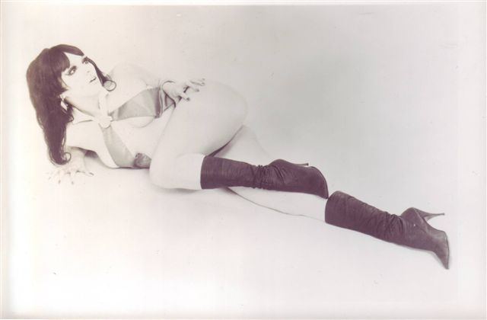

Heidi's costume was made of polyester and cut like a swimsuit but it still looked great. She even had a paper-mache bat! I love attention to details! Man! I would've loved to have had a paper-mache bat...

Speaking of the paper-mache bat, I spoke with a very nice lady named Perdita Boardman, who confirmed that she actually made Heidi’s Vampirella outfit from the bat to the boots, with the exception of the jewelry. Perdita and John Broadman were great friends of Art Saha, Heidi’s father and Perdita readily agreed to use her considerable costume skills to recreate the Vampi costume when Heidi’s mother, Taimi asked her for help.

I believe that Heidi’s parents had Perdita make the costume because they needed a professional looking outfit for the promotions that Jim Warren wanted to set up. Perdita was not aware of this aspect and considered her work on the costume as a favor to a friend. Heidi’s mom was very proud of the fact that she made all of Heidi’s costumes herself but, in this case, her skills weren’t good enough for Warren’s demands for complete perfection, which was a trademark of his.

By the way, I heard that Heidi sold the costume at an auction house a few years ago—I wonder if that’s true and how much it sold for?
Meanwhile, back at the 1973 masquerade, as I was waiting around, I noticed that Heidi seemed sad—like she wished she could be somewhere else. Everyone else was having a great time but I couldn’t help but wonder why this girl was so unhappy. I wanted to talk with her but my friends said I had to go off and get registered—remember, it was my first competition and I have no idea of what to do. So we went to the registration area. By the way, it took me years to figure out that not every costumer has their own entourage…
It was around this point that a short, thirty-something woman with long brown hair strode in, looked at my costume, scowled, and proclaimed, "Oh, that's so tacky!" and left in a huff. I was like: Who was that? What? No hello?
My friends explained to me, "That's Heidi's mother, Taimi Saha."
Well, it seems that Mrs. Saha hated me from the moment she saw me because she thought that I was stealing her baby's thunder. I didn’t mean to mess up her plans. I just wanted to enter the masquerade as my favorite character. But to Mrs. Saha, this was supposed to be "Heidi's con & masquerade” and I was viewed as a potential threat.
Heidi could not have cared less but her mother did, a lot, so she tried to get me barred from entering the competition on the grounds that my costume was cut too low. This was news to me as I was unaware of any problems with it before—after all, it WAS a Vampirella Costume.

Anyway, it was Phil Seuling who came to me and told me that I would have to do something about that if I wanted to enter. He was very nice about it but he felt that he had to back Mrs. Saha on her concerns for decency.

So, let me get this straight, she's parading her underage daughter around in sexy costumes and she's concerned about decency? Sheesh!
Well, my friends weren't going to let that happen. One of them came up with an idea and ran off to get a box of band-aids from a nearby drug store so I was able to cover the "offending area" with the flesh colored band-aids and thus I was allowed to enter the masquerade. And I haven't been able to deal with those sticky little buggers since... {laughs}
I went on before Heidi and the audience went wild when I dropped my cape and posed and played to them. I think that Heidi went on last and stood there with the paper-mache bat held aloft in a copy of the pose of the Gonzales poster and again, the crowd went crazy. So you can imagine my confusion when a short time later, parts of this same crowd started to boo and jeer when it was announced that Heidi had won 3rd place.

Maybe they thought she should've won a higher place? That would have been understandable as I thought that her costume was excellent.

However, it seems I didn't know about the politics of the situation at that time which, as I was later told, were the reasons for the audience's reaction. However, if the crowd had a problem with James Warren or her parents, they shouldn’t have taken it out on an innocent kid!

Poor Heidi. She stood on that stage, holding her pose like a real trooper amid the boos and heckling—it must have hurt like hell.

I felt so bad for her at that moment and in that moment, I gained a lot of respect and admiration for that young lady. I also got some precious insight into mob mentality: it’s a very scary thing!

As it was, Cortlandt Hull’s wonderful Ming the Merciless won first place and Darkseid & Co. took second--sorry I didn’t get their names.
Despite not winning, I still had a great time and I got a really cool drawing of me as Vampi done by Sergio Aragones himself. He was one of the judges and drew it up on the spot for me when I visited a friend at the MAD magazine offices. He even added a bat to my hand! What a guy!! That was one of the best “prizes” I ever received!

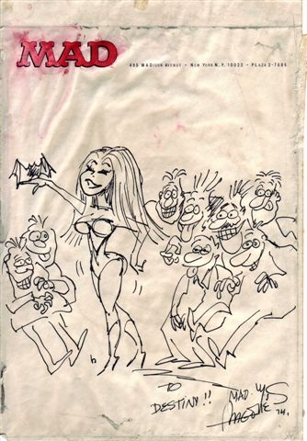
While at this con, I met Anthony Tollin and Gerry Boudreau, who were writers at Warren. Anthony suggested that I should visit the offices of Warren Comics and meet Bill DuBay and the other hard-working comic professionals. So I did! I think it was about a week later that I visited and Gerry showed me an article he was working on about the convention that was to feature a picture of Heidi in her Vampirella costume. It was a professional photo of her standing stiffly holding the bat next to her face. Still, it was a very cute shot.
Gerry then asked me if I had any professional shots of my Vampi and I said no. So he talked with his editor, Bill DuBay, and discussed the idea of including me in the article. Bill loved the idea and I was given the name of a photographer they knew that could do the shots quickly. I was told that I had to get my pics to them asap because the article was going to press soon.
So I upgraded my boots to look closer to the poster and got some great pictures within the week! Thank God for shoemakers, matte black spray
Paint and reasonably priced (good natured) photographers!
Gerry and Bill loved the pictures and they decided on the one that appeared in the finished article. Bill also picked a different pose from Heidi's shots because he felt that it would improve the article
I heard that Mrs. Saha was not very happy when she saw the article in the November issue of Vampirella #29: "Two Vampirellas Stun 5,500 at 1973 Comic Art Convention". Well, everyone I knew loved it.
I would always say "hi" to Heidi whenever I saw her at cons—we’d talk about astrology & stuff but not a lot because her mom might be lurking nearby and neither of us wanted a scene. Mama had some serious issues.
My heart went out to Heidi in that she was just a sweet kid who wanted a normal life but her mother was bound and determined to make her baby a “star” regardless of what she wanted.
Actually, I could relate to that in that my mom could be very heavy handed at times and would make me crazy too. Still, I loved her and miss her terribly.
I think that Heidi wanted to be an adult as soon as possible so that she wouldn't have to put up with her mother's nonsense, but even today, although in different cities, they still stay in touch. Heidi simply learned to take her mom’s moods in stride.
I remember one of the last times I saw her was at a Star Trek con in early 1975. She was dressed in a pink jumpsuit and her hair was a nice shade of brown. She wore tinted aviator glasses, pretty hoop earrings and had a small jeweled decoration on her cheek—the kind of thing a 16 year old would wear. She was very happy and relaxed.

She wasn’t entering masquerades anymore, not since some very unsavory stuff went down at the July 1974 Seuling's Comic Art Con. I believe that Heidi's father, Art, decided to put a stop to the costuming activities which pleased Heidi to no end. I was very happy for her too.
Sometimes I think it seems kind of odd that Heidi and I are forever tied together just because we wore the same costume to the same comic-con so many years ago. Funny how things work out.

After my first appearance as Vampirella, I wore the costume to a few Halloween parties and entered it in the masquerade at the San Diego Comic Con where I met the future Brinke Stevens. She was wearing a Vampirella costume too. Remember what I said about fan-girls?

Eventually, I decided to upgrade my costume and made a new one that had a long skirt added to it that I’d seen in a Vampi story drawn by Gonzales. I entered this new version of Vampi 2.0 in the Famous Monster Con masquerade in Nov. 1974 as “Vampirella’s Evening Gown”. When I stood on stage, I waited a moment and then whipped off the detachable skirt to reveal the more familiar and beloved Vampi costume underneath to a very appreciative audience and judges’ panel. I won 3rd place for my efforts too. By the way, you can see all of the masquerade winners with Forry Ackerman and Jim Warren in Famous Monsters #115’s coverage of the con.

Later, I designed my own version of this concept as an entry in the 1977 Star Trek Con’s Future Fashion Show. My ”Drakulon Evening Wear” won 1st place Alienwear.

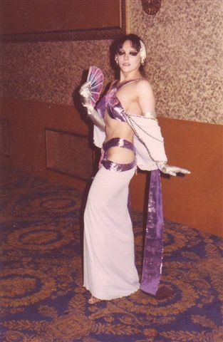
Drakulon Evening Wear

RA: How did Jim Warren respond to your Vampi appearances?

AT: I would often visit the offices of Warren Publishing to see my friends who worked there and my first encounter with Jim Warren was memorable. One day I was talking with Bill DuBay in his office when Warren walked in. Bill introduced me and added, “Hey, Boss, doesn’t she look like Vampirella?”

To which Warren snapped ‘Yeah—around the chest.” and walked out.

OK, so he wasn’t crazy about me but I really wanted to do promotions as Vampi for his company so I asked him about it.

Maybe my timing was off, or more likely, I never had a chance in the first place but Warren invited me into his office and proceeded to tell me that I was not Vampirella material. He picked up a picture from a pile on his desk—it happened to be a shot of Jane Fonda’s Barbarella--and explained that this was the level of perfection he was looking for in anyone who would represent his property whether it was at a convention or on screen.

So I guess that was a “No”…?

Ironically, I did end up in one Vampirella issue by chance. When I met Neal Adams at a con, he told me that he had an art studio in New York and that I was welcome to drop by anytime. I decided to do just that and since I was going to take a cab anyways, I wore my Vampirella outfit under my coat to surprise him.

As I shed my coat and Neal saw the costume, he did what any red-blooded man would do when faced with a scantily clad pretty girl—he immediately drew a picture of me!

Hello, artist…what were you thinking?!?

That sketch appeared as the frontispiece of Vampirella #44, and if you look closely, you’ll see me as the model with my coat still clutched in my left hand.

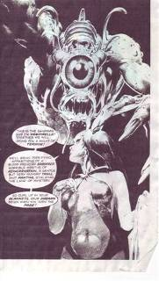

By the way, Neal was the art director, costume designer, and illustrated the poster/Playbill cover for Warp, a science fiction stage play by Bury St. Edmund and Stuart Gordon that had some cult success in Chicago in the mid-1970s, and played on Broadway for a too brief time.

The other appearance I’m actually not too sure of, but the cover painting for Vampirella #32 sure looks a lot like me in costume. That happened a lot. I’d often pose for a picture at a con and find a painting of me on a cover of something a while later.

Jim Warren did talk about his experience with Heidi Saha in his 1990s interview that appeared in The Warren Companion which, by the way, is an excellent book for anyone interested in the Warren Comics line.

He mentions that he met Heidi when she was 14 or 15 but I’ve seen at least one photo of him posing with a younger Heidi, probably taken at Lunacon in 1970 when she would have been 11. Heidi’s father, Art Saha, was at one time president of the Lunarians, the group that sponsored LunaCon.

Warren knew the Sahas through his friendship with Forry Ackerman and Forry had known Art since the 1940’s when he was a young science fiction fan living in Forry’s hometown, Los Angeles.

Hey, it was a long time ago so no one can fault him for not having a clearer memory about this.

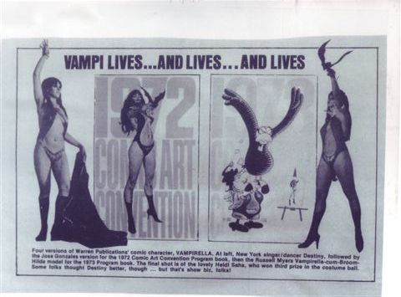

Warren explained in his Warren Companion interview that publishing the Heidi book and poster was part of a deal he made with her parents. He said “it was my way of paying them back for Heidi wearing a Vampirella costume, promoting a Warren property”

Warren went on to say that he thought that her parents “were grooming her to be a movie star and if she had her own magazine and poster, it would be a step in the right direction.”

I believe that Warren arranged for two interviews with Heidi that followed the 1973 ComicArt con. One was in the Sunday Daily News (7/15/73) and the other appeared in the Potpourri section of a 1974 issue of Playboy. That Playboy appearance wouldn’t be that unusual since Warren and Hefner were acquainted.

Everything seemed to be going very well but then a serious problem occurred at Seuling’s 1974 ComiCon and the Saha family immediately withdrew Heidi from the promotions.

A friend of the Sahas remembers “being with Taimi in a con suite back then when she became quite tearful and distraught when it dawned on her what she was doing to Heidi. I think she pulled back on the stage mother stuff thereafter.”

By the way, for people who wonder whatever happened to the magazines and posters, here’s what I know: when Warren’s company went bankrupt in 1983, Forry Ackerman, also a friend, called me from California and asked if I could do him a big favor.

He was worried about the many photos that he loaned Warren over the years. It seems that most had never been returned to him and he wanted them back before the impending bankruptcy sale. I gladly agreed to help him and went to the Captain Company. I looked everywhere for Forry’s photos but sadly, I could only find a few to return to him. The rest were gone. During my searches, someone told me that Heidi’s magazines and posters had been removed by either her parents or people representing the Sahas in order to avoid having them sold off at the auction. What happened to them after that is anyone’s guess—

By the way, in regard to the Vampirella movie, it’s really a shame that Warren never got to make his version of the Vampi movie with Hammer Films as he had intended. I think that Barbara Leigh would have been perfect as Vampirella and I suspect that the movie would have lived up to our expectations. Hammer Films, however, had its own problems. They were seriously hurting for money and took on other investors which caused many arguments between Hammer & Warren about everything. It was the disputes about the merchandising rights that caused the most problems and sadly, Hammer went bankrupt during the delays.

I liked your interview with Barbara Leigh and I remember laughing out loud when I read DuBay’s interview in The Warren Companion relating the time when he and Barbara first met and they faked out Jim Warren with that kiss! I liked the way she handled things--she’s definitely my kind of people!

Although we never met, I helped Barbara when she first appeared as Vampirella at the Famous Monsters con in 1975. It seems that she was having trouble with staying in the costume and a friend from Warren’s found me and asked what I did to keep everything in place. I used, of course, double-sided tape, which wasn’t nearly as well known then as it is today.

Both Vampirella and, later, the Satana costume were gravity-defying outfits. You could do them one of two ways. You could cut them wider so that they covered enough or you could make them as they were drawn and use two-way tape, which is also called carpet tape. It’s strong and super-adhesive on both sides. You tape one side directly to your body, the other to the part of the costume that needs to stay put and in most cases it worked beautifully. I hope that “the costumer’s secret weapon” was of help to Barbara that day.

When it comes to costumes, it’s all about bringing the fantasy to life. A drawing doesn’t have to worry about falling out of the costume but a real person does. While it’s ok to look like you’re going to fall out any minute, it’s not ok if that actually happens. The tape allows the fantasy to play on.

I remember an interview with one of my heroes, Elvira, who talked about the same thing with her costume. In her case, the costume was built on a very strong corset and because of her “industrial strength bra”, her breasts may look like they’re going to fall out but she affirms, “they ain’t goin’ nowhere”. Believe me, that’s a great feeling!

RA: How did the Satana costume come about?

AT: After the masquerade in 1973, I was hooked so I searched for a suitable challenge and found it in Satana. The costume was sexy and not too easy. It also involved some hand-made touches that I could do and I sensed that it would be a crowd pleaser.

Again, with the help of my friend, Stephanie, I was able to recreate the costume and, this time, we were very careful when we cut out the center area as I didn’t want a repeat of the previous year’s troubles.

I embroidered the ram’s head symbol on the cuffs and made a 3-D ram’s head decoration out of paper mache and beads that was on the hip of the bodysuit. The fur boots covers had similar pieces on them as well. I topped off the effect with my very long human hair red wig and even managed to jury-rig a small widow’s peak. Then I used red pipe cleaners to make her distinctive eyebrows, which I then glued to my own. Yeah, I know: costumers are crazy! I added some double-sided tape to the right places and I was good to go.

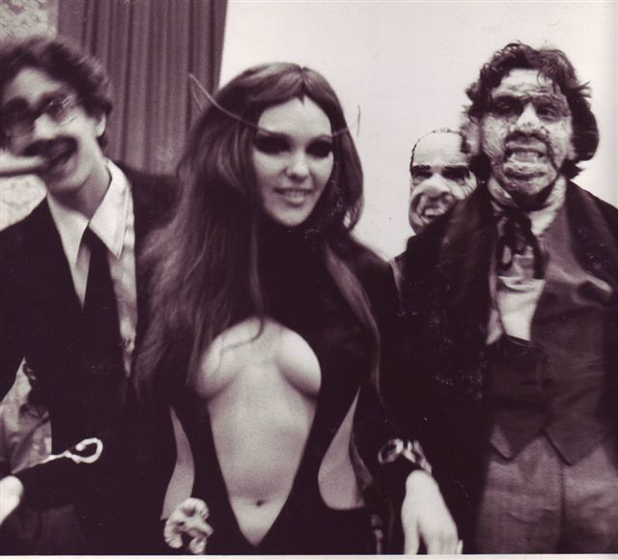

I met Tony Isabella while wearing the Satana outfit and he’s been a great friend ever since. I asked him if he had any memories of those days to help fill in my lapses and he answered “Memories of you? I think I wrote a letter to Penthouse Forum once! :)”

“Seriously, I remember that just about every guy I knew, including me, had at least a little crush on you. I remember the Vampirella and Satana costumes. I think we met at some convention when you were wearing the latter. I had just become Satana’s editor in Haunt Of Horror… My memory is that you visited my office at Marvel in the costume when we were talking about doing some sort of Satana photo-story, which I would have written and you would have starred in. As you can imagine, some of the older production people were surprised. One of them, I can’t recall who, asked me later if you and I were dating. I think I might have told him something like, “No, my girlfriend usually wears a Tigra costume.”

Tony added, “I mostly remember that you were always at these shows and everyone knew you, everyone liked you. That Satana costume (and you in it) still knocks me out every time I see it. So sexy and sinister, but not without its sweet aspect.”

Thanks, Tony, for remembering so much of those great old days!

I entered Satana in Seuling’s ComicArt Con in 1974 along with my best friend, Kris Lundi, who entered her excellent Hawkgirl, which included an amazing pair of handcrafted feathered wings. We both tied for 3rd place and that was fine with us because the only thing better than hanging out with your friends is costuming with them.

Kris would later change her name to Animal X and become a major influence in costuming on her own. She inspired me to do wonderful costumes and is one of the reasons that my work is included in ‘The Costume Makers Art”, which is a glorious book about costumers and their creations that Animal spearheaded to the attention of the publishers. I often tell people that I would have bought the book even if I wasn’t in it—it’s THAT good!

RA: Can you give us any details about the costumes that you’d care to share?

At: OK, since you asked, let’s talk costumes! Since 1973, I’ve made about 105 costumes or pieces—give or take a beaded necklace or two… I’ve always liked recreating comic book characters because the outfits are so recognizable to the fans and fun to portray. Among the costumes I made from DC Comics for myself and others were Wonder Woman, Superman, Supergirl, Starfire (not the same character as Marvel’s Princess Kori “Starfire”), Batman and Batgirl. Marvel Comics also offered up some wonderful characters as well. Beside the aforementioned Satana and Red Sonja, there was Rogue, Dejah Thoris and Spiderman. All some of my best work.

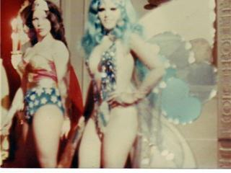
Angee’s sister Keri (in the Wonder Woman suit) & Angee as a butterfly! Artist Ernie Chan was so impressed by Angee’s butterfly costume that he drew a sketch of it on the spot!

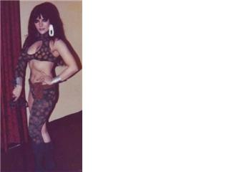
Angee as DC’s Starfire

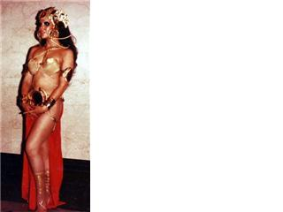
Angee as Dejah Thoris

I found that I enjoy certain elements of costuming like design and engineering as well as beadwork, wing making and recreation. I’m also a natural born performer (H-A-M) and dreaming up interesting, fun presentations is another aspect that I enjoy as well.

All of these components come into play when I’m working on a costume and I was able to hone my costuming skills first through the many Comicons, Star Trek cons and SF cons I attended. People like Animal and other creative fans helped me to go further than I would have thought possible.

Through my involvement with Rent-An-Alien, which was an unusual costume business created by Peter Mosen, I was able to expand my repertoire with costumes I probably wouldn’t have tried on my own. Frankly, that’s what made it so rewarding and interesting.

After I left Rent-An-Alien, I joined Animal in many of her costume adventures and business ventures—which was too much fun! (like the time we loaded a 20 foot dragon into a taxi—ok, two taxis…)

In the early 1980s, there was a new kind of convention—CostumeCons! They’re like the WorldCons in that they’re held in a different city each year but they consist of wall-to-wall costume programming with no less than 3 competitions: a Science Fiction/Fantasy Masque, a Historical Recreation and a Future Fashion show. They’re really amazing, exciting, funny and educational too and so worth the trip!

In the late 1980s, I met another fan, Kristopher Curling, who had his own fan-based comedy group called, “Doctors In The House” which specialized in Dr. Who comedies and which later branched out into other fan favorites. With the ‘Doctors’, I was able to perform comedy and create some very specialized costumes for the instant costumes/character changes backstage.

By the way, our sketch comedy also had a unique element too: it attracted some of the attending celebrities to join in performing with us. I’ll always remember fun-loving Denise Crosby (Lt. Yar from ST:TNG) gleefully teasing the audience while holding a bundled baby, “Would you like to see my baby?” and then revealing the baby was a toaster. When the laughter subsided she touched her communicator and said wistfully, “Data, We REALLY have to talk!” …the audience lost it!

We even attracted Star Trek writer, Peter David, who asked us if we would perform his Trek play at one convention. We had the added honor of having Worf performed by Michael Dorn himself! He was really funny too—great sense of timing and his deadpan delivery really had the audience and us in stitches.

Out of the 105-ish, there are five costumes that I think stand out.

- Vampirella was my 1st costume for competition and a sort of baptism of fire for my entry into masquerades. Vampi still stands out as a fan favorite. It’s really amazing how many websites are dedicated to Vampirella. One of the first sites I became involved in was one run by superfan Terry Sanders from Kentucky who put together many of the “live Vampi models” fact pieces that one finds all over various Vampi sites. Terry spent a great deal of time and energy, both setting up interviews and posting the model’s photos to Mike Grace’s website, “Vampirella Revealed”. He also managed to get some fine pictures of many of the current Vampi models, both solo and cozying up next to him—he is the envy of many a Vampi fan—trust me. You can check out his site at http://dspace.dial.pipex.com/town/way/rbp20/models/sanders.htm and while you’re there, you can click on my name and read my first online Vampi interview.

Speaking of Vampi fans, Robin Whale, the creator of an unbelievably extensive site called Vampilore credits a former site, Vampifan.com with inspiring him to build Vampilore. Robin explains, “I used to use Vampifan as my primary point of reference for my collection, and then one day it was gone. The lost of Vampifan was one of the main reasons I decided to build Vampilore!” Robin points out that Vampifan.com’s original owner was Scott Stockwell who was said to have gone to the Far East in his role as an Army Doctor and has not been heard of in the 18 months or so since. So if anyone knows the whereabouts of Scott Stockwell, please let me know or contact Robin through his site at www.vampilore.co.uk/ By the way, I think you’ll love his site too—I’m especially fond of the Interactive Vampi Paper Doll Section.

I’d also like to add that before Seuling’s 1973 con, I would often make costume-like clothing for myself just for fun. Some were based on my own designs or copied from something that impressed me, such as the first Broadway musical I ever experienced, which was “HAIR”. HAIR’s costumes were exciting and inspirational and the show’s message and spirit still soars within me. HAIR set the tone for my life in a way: it crystallized a youngling into a thinking, questioning and creative adult (who doesn’t mind using a George Lucas term every so often…)

One of the HAIR costumes I recreated for myself was a silver lame (pronounced “lamay”) pants & crop top from the song ‘The Electric Blues’. The outfit was covered in tiny mirrors which looked good on stage but, as I learned, were very hazardous to actually walk around in.

- A Lady from Wrigley’s Pleasure Planet (or LWPP or just “Lady” for short) was my first original design that won an award. It was based very loosely on a mention of the planet in a Trek episode. I made that one for the New York Star Trek Con in February 1975. Very pretty and glamorous and yes, scandalous too—it was mentioned in Joan Winston’s book, “The Making Of The Trek Conventions”. I quote: “Most of the costume was on her head—lots of plumes, ribbons and beads. The rest was some sort of panel arrangement fore and aft that displayed a lot of Angelique.”

At that particular con, Joan was a masquerade judge which gave
her a unique perspective. Three of her fellow judges were Star
Trek and movie costume designer, Bill Theiss, actor Robert
Lansing and writer David Gerrold, of whom she wrote “David
should not have been there. He was running a fever—even before
Angelique Trouvere appeared in what there was of her costume.”
It’s ok, Joan’s a friend—really!

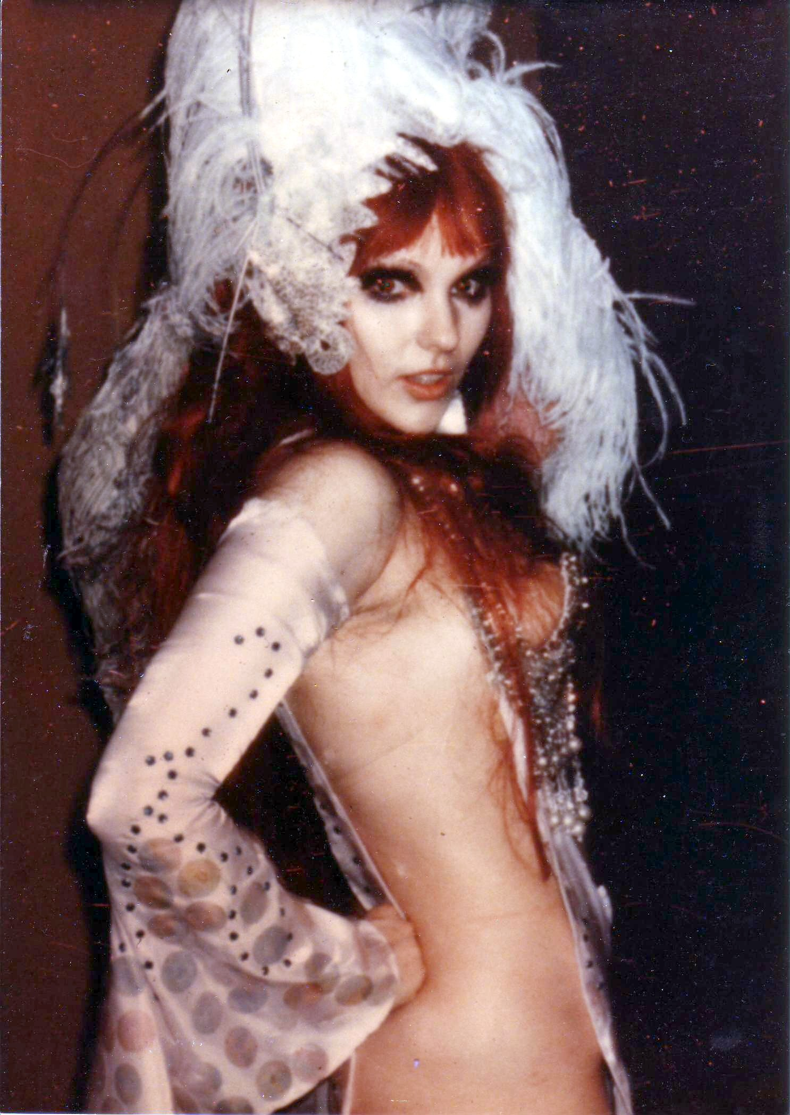

I also loved her bit that she added regarding the decision to
award “Most Beautiful” to me—“The males on the panel, however,
after they retrieved their eyeballs from across the room,
decided on Angelique.” Joan always had a great sense of humor.

By the way, I met Bill Theiss a month earlier at the January
1975 Trek con when I wore my version of the silver Shana costume
from the episode, “The Gamesters Of Triskelion”. He was a very
sweet man who graciously complimented my work and added “Your
Shana was much better than the one on the show.” When I asked
in what way, he playfully poked my breast and said, “Yours are
real, hers weren’t.” Well, at least he didn’t award me “Breast
In Show”…

Anyway, the Lady was a fairly simple costume in that it
consisted mainly of front and back panels. There was a lot of
skin showing because there was nothing else on the sides. My
bra, which was heavily beaded and matched the collar, held up
the front panel. People thought I was naked under the panels
but I wasn’t. It was an optical illusion I designed when I used
nylon wire to stabilize the bra on the sides and then I arranged
a matching panty to stay in place by using the nylon wires in
place of the regular sides. They ran up to the bra strap fore
and aft under the panels and thus I had no visible panty lines.
The sleeves stayed up with good old reliable two-way tape and I
just went to town on the headdress and high heels too! I had
the best time constructing and bringing this design to life.

Later on, while Kris Lundy and I were walking down a hallway
after the masque, still in our costumes outfit, we ran into
Robert Lansing—he was very charming and flirted with us. He was
a little blitzed but very sweet.

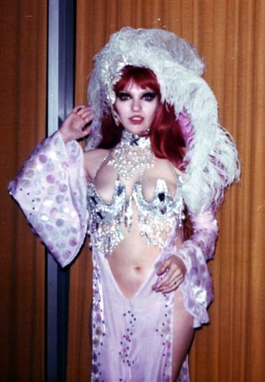

A short time later, I entered this design in a Future Fashion
Show at a LA based Trek convention called Equicon. Bjo Trimble,
the lady who saved Star Trek, wrote me a lovely letter
telling me that my design had won 1st place in the Eveningwear
division in spite of some opposition to its winning a place in
any category. Bjo explained, it seemed that the young woman
running the con was “somewhat religious” and thought I was
“terrible for running around in all that bare skin.” However,
Bjo, and her husband John, went to bat for me and got the design
approved because it was an nice example of what people might
wear on other planets. She wrote “…you can be trusted NOT to
get us all arrested.”

I’ve always admired and respected Bjo ever since she spearheaded
the letter writing campaign to save the original Trek but now
she had my friendship and affection too. Bjo was indicative of
the warm-hearted, extremely creative and fun people I met at my
first west coast convention and I found both the cons and the
people great reasons to return to California every chance I got.

- Red Sonja. I made this for Seuling’s ComicArt masquerade in 1975. It started out as a basic bikini that I made out of a heavy silver fabric to which I added the triangular flaps in front and back of the bottom. A pair of large hoop earrings held the sides and flaps together. I then sewed silver sequins to the two pieces and cut out the shoulder piece, called a yoke, and bra decorations from mylar. I added some suede-like straps decorated with sew-on jewels that glamorized the boots and the armband, as well as a thigh strap which held my dagger. I customized a pair of brown gloves and added my long red wig to complete the look of what was then Marvel Comics latest heroine. I knew it wasn’t perfect but I was pleased with my efforts and was happily surprised when it was announced that I’d won 2nd place.

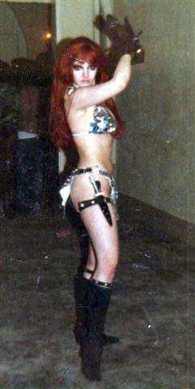

Funny thing about Sonja—she always seemed to demand respect and
I found myself constantly upgrading her over the next few years.
For example, I sewed down the sequins which I sprayed with a
matte silver paint to give them a more realistic look. I also
used that paint on my new yoke that I cut from a very strong,
yet lightweight fabric called buckram. The hoop earrings I’d
used on the sides were also replaced with larger and stronger
plastic curtain rings. Later I completely redid the boots and
gloves to match Frank Thorne’s drawings, using slippers and leg
covers with elastic suspenders. The sequins were eventually
replaced with actual metal disks in which I punched tiny holes
so they could be sewn on the bikini, then later on I replaced
those with smaller, metal shank buttons which made the costume
look and feel more authentic. I was on a quest for the best Red
Sonja costume I could produce. She was always a labor of love
and one of my best loved recreations.

- Another costume that I’m very proud of is my Daggit costume from the 1978 version of Battlestar: Galactica. This was my break-away costume! Up to that point, I had always been known for my sexy lady costumes. Daggit allowed me to show a totally new side of my costuming skills.

This epiphany happened when I first met a very talented costumer, named Peter Mosen, at Seuling’s ’78 ComicArt con Masquerade. I was wearing a beautiful Elinor costume (from the film ‘Wizards’) that had been recreated by Elfquest writer/artist Wendy Pini for an earlier Worldcon (SunCon ’77). She went as WeeHawk and together with her Elinor, she won “Most Authentic Fantasy.” She’d contacted me a few months before Seuling’s con and asked if I would like to have the costume. I remember her writing “Angie, it’s a prize winner!” It was a sweet gesture and I never forgot her kindness. By the way, it’s not unusual for a costumer to give away their costumes to a good home. I well remember the intense joy and excitement I felt at receiving a headdress that I admired at a costumer’s party one night and I like giving others that same great feeling in return.

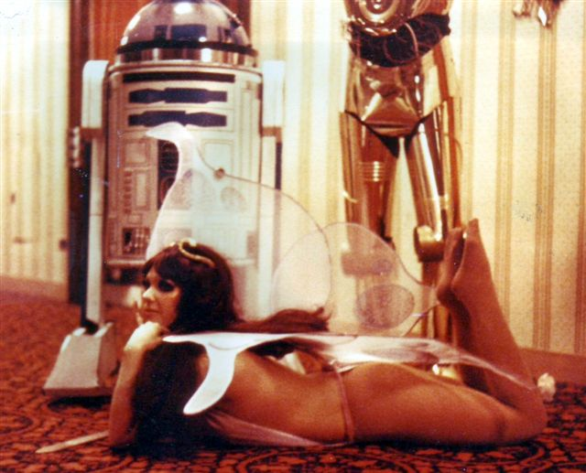
“Angelique as ‘Elinor’, in a costume recreated by Wendy Pini, with Peter Mosen’s C3PO & R2-D2 in the background!”

When I met Peter Mosen, he was wearing his amazing recreation of C3PO which included an excellent R2-D2 recreation as a rolling prop! Peter added a cassette player to R2-D2’s innards and whenever he hit a switch, it made R2 sounds, which was very cool and unexpected for that time. His creativity and workmanship with hard materials like plastics, metals, etc. impressed me and because Peter could not sew or work with soft materials as I could, we decided to join forces.

A few months later when we first saw the pilot episode for the original Battlestar Galactica, we were blown away. Peter immediately began making plans to recreate a Cylon Warrior. I considered recreating one of the ladies’ outfits but their costumes weren’t very challenging. However, that Daggit costume was a whole ‘nother story!

In the show, the Daggit was a costume actually worn by a chimpanzee named Evie. For my costume, Peter made the non-fabric parts, just as I made the fabric parts for his Cylon Warrior. I was able to easily solve his costume problems by sewing a gunmetal colored vinyl onto the heavier mylar for his pants and then made a matching top with sleeves, to which I added thin plastic tubing under the vinyl that encircled his torso.

Peter was then able to craft the cylon’s various armor pieces out of chrome mylar with the piece de resistance being a working cylon helmet. People could not get over that crazy red eye that moved back and forth at different speeds—oh, those innocent ‘70s…

Peter used this same mad scientist ingenuity when he worked on
my Daggit mask. He put together the facial pieces of the Daggit’s face using plastic Christmas ornaments, bits from old model kits and basically anything that he had that was handy. Peter kept EVERYTHING, believe me! We also used the costumer’s secret weapon—L’eggs Eggs—another gift from the ‘70s. Look closely at my Daggit’s face and you’ll see them.

The costume itself consisted of three main parts: pants, top and mask. I attached the hooves to the pants—think footsie pajamas, furry and silver sectioned footsie pajamas—to keep things simple. The costumer’s nightmare is not having important parts of the outfit when you’re getting ready to go on stage. By the way, ALL parts are important!!

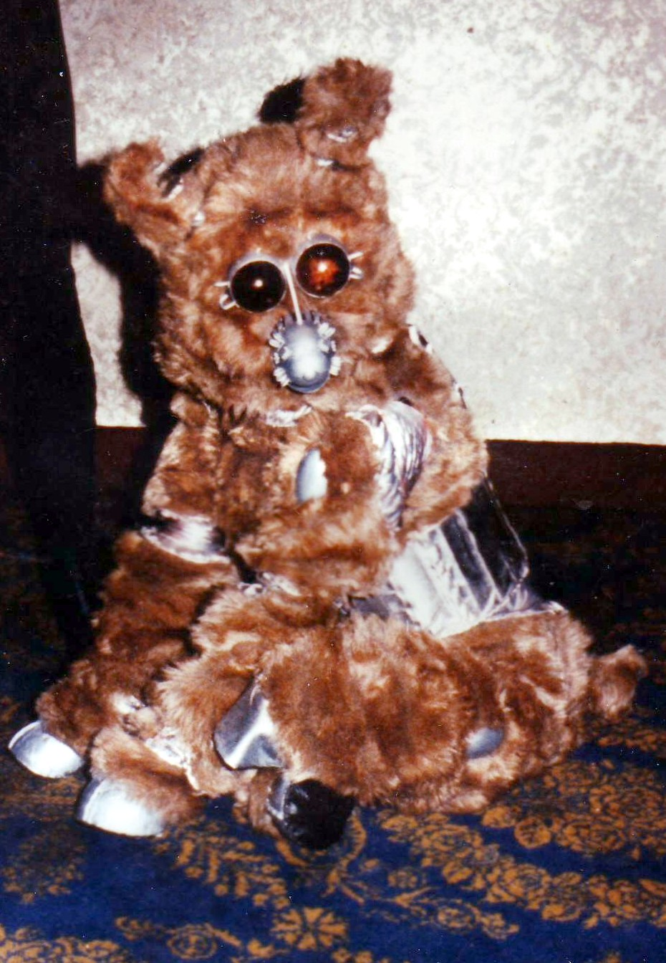
ANGELIQUE’S DAGGIT COSTUME

I didn’t quite realize it at the time but this costume ended up taking an amazing amount of physical commitment on my part. Still it was worth every sweaty moment! I would often refer to myself as a furry astronaut as a joke—although come to think of it, it would have been nice to have a mini air conditioner inside the mask.

Peter added an electrical set-up inside the mask and a battery pack inside the top. Finally I added the matching lame over mylar belt and Viola! Cute little furry droid from outer space!! By the way, I sewed this costume by hand as I’d done with all of my costumes up to that point. It wasn’t until later that Peter gave me a sewing machine to help out.

When I entered the Daggit in the NY Star Trek con in February,
1979 I decided I wanted to be judged on my abilities alone and
not my name or reputation so I didn’t give my name on the
announcer’s form. I simply titled the entry as ‘R2-D2’s best
friend’ and waited for the fun to begin.

Once I left my room in the Daggit costume, I spent as much time
as possible in character and on all fours which I’d prepared for
with some practice and with deep gratitude to my flexibility. I
was able to walk on my hands and toes by keeping my legs tucked
in tightly to my sides and letting the fur help in the
camouflage.

When the announcer called out for “R2-D2-s Best Friend” to
appear, I walked out to great cheers and applause. Then when I
got to center stage, I sat down like a dog and used my secret
weapon—I pressed a rocker-switch with my right hand that was
inside the hoof.

This simple unseen action caused my Daggit ears to TWIRL! The
crowd went nuts!! Peter had rigged up an electrical system
inside my costume and the mask to make that happen. The mad
genius had set my ears on a pair of tiny racing motors attached
to a metal plate which sat on top of my head. I worked the
rocker-switch to slow down the movements because those tiny
motors were fast!

I continued in character as I exited the stage and waited for
the judging which wouldn’t be for another hour or two—I think I
was in costume for about 4 hours total but I wouldn’t break
character.

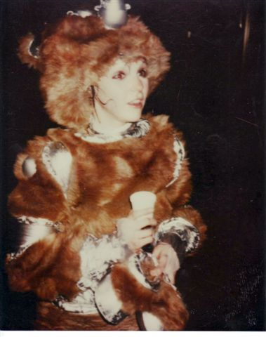
ANGELIQUE AFTER A 4 HOUR DAGGIT STINT!

Finally, the awards were announced and each Star Trek celebrity
who had been a judge came forth to hand out the trophy to each
winner. When I heard my entry called as the winner of the 1st
Prize (Best In Show?) I headed back to center stage where Grace
Lee Whitney had squatted down to present the trophy to what she
clearly thought was a youngling. She called out to me, “Come
on, Sweetie! Come get your prize!” I moved towards her still on
all fours. Then when I got close to her, I again sat down,
twirled my ears and removed my front hooves so that I could
carefully remove the daggit mask and finally get some air and
allow the audience to see me.

Grace was so stunned that she fell on her behind as she cried,
“It’s a girl!” The as she got up, she recognized me and said,
“It’s YOU!” and at that point I stood up to an equally stunned
audience and took my bow. It was one of the best moments of my
life.

- My final notable costume represents the pinnacle of my costume
journey. It called on all of my skills and resources and became
my crowning achievement—literally. My lords and ladies, I
present to you the true monarchs of costume & comedy: Queen
Elizabeth I and Lord Blackadder.

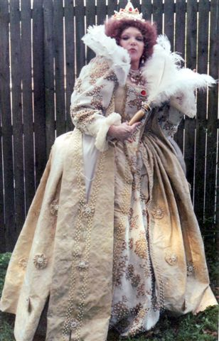

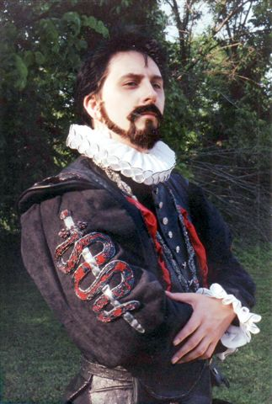

These two costumes were recreations from the British comedy,
‘Blackadder II’. Produced for British TV in 1985, it was shown
on Public Broadcast Systems all across America a few years later
to rave reviews and besotted fans everywhere. Among those fans
were myself and my friend, Kris Curling, who directed the
comedic antics of the fan-based comedy group, “Doctors In The
House’.

In 1990, we heard that a Costume Con was scheduled for Columbia,
Maryland in May 1991. I decided to recreate the two Elizabethan
costumes and characters for the Historical Masquerade with Kris
as Lord Blackadder and myself as Queenie.

Not only could Kris portray Blackadder beautifully but he could
ad-lib too and all that was required of me, besides making both
costumes, was that I play her majesty as a ditzy bimbo—no
problem!

The two outfits were awe-inspiring recreations of Elizabethan
finery and something I’d never tackled before but I felt
confident that I could make this perfect pair for the upcoming
masquerade. As I mentioned earlier, CostumeCons (or CCs) are
very different from other cons and the CC’s Historical masques
were not for the faint-hearted. I was almost terrified of
entering one but in 1990 I felt that Blackadder couple signaled
that my time had come.

While both costumes were complex I knew that my experiences with S/F and comic character costuming would be essential in their recreation.

It was a lot of work, both by hand and machine, but I had to admit that when I finished it, Queenie and ‘Adder were a very impressive sight. I could see why the Elizabethans would have worn such complicated clothing. It made them seem more unearthly and glorious.

See? You actually learn stuff when doing historical costumes!

As grand as the costumes were, it was our presentations, written by Kris, that gave us the edge over the competition. Kris devised a really funny and yet simple presentation for us. He sought out the masque’s MC, Ricky Dick, and asked if he would go along with Kris’ script. Ricky agreed and when our turn came he pretended that he couldn’t make out the handwriting on the entry card.

“Entry 21:…Lord…Edna? Black slat…no, Black tickler…no, Edna…” at which point Kris in full Blackadder regalia storms on stage and jumps down next to Ricky.

“Get out of the way! Get out of the way! You really are a pratt, aren’t you?” as he easily took over the podium amid cheers and laughter from the audience.

He continued “Are you related to some dungball named Baldrick by any chance?” More laughter. “The name is Edmund Blackadder and I’m sure you’re all honored to be here!” When the cheers and laughter died down he went on, “And now without further ado, may I introduce to all of you: M’lords and Ladies, assorted peasants---and that spotty, little bastard in the front row.” He pointed to no one in particular and the audience loved it! “I want you to give an appropriately regal welcome to the so-called ‘Virgin Queen’—at which point I was still behind the curtain but I made a shrill chirp that meant Her Majesty was not happy at that so-called crack—Blackadder quickly amended, “The Virgin Queen, Queen Elizabeth!” As he turned to join me onstage, Blackadder quipped to Ricky, “It’s all yours, privy breath!” The audience went nuts as we playacted across stage and exited.

Now, the reason I just wrote out Kris’ script was to tell you of a funny thing that happened while we were in the main area awaiting the judges’ return.

I watched Kris play ‘Adder to the hilt—the great thing about Kris was that not only could he easily deliver lines and insults from the show with the proper cynical invective but he could improvise his own insults to suit the victim. It seemed that everyone wanted to be insulted by Blackadder that night. So as Kris was standing before me, I saw a woman I knew come up to him, throw her arms around him and tell him that he had given her the best convention ever! That he’d said things to Ricky that she’d wanted to say for a long time. She thanked him over and over. Kris stood there completely befuddled and after she left he asked me if I knew that woman. I answered, “Yes, that’s Ricky’s ex-wife.” (insert rim shot here)

Finally, it was time for the awards and as we neared the end of the ceremony, the last award was announced “and Best in Show for the Historical Masquerade of Costume Con 9 goes to Blackadder and Queen Elizabeth!”

I was speechless—literally! All I could do at that moment was giggle because I was in shock. You see, normally, only a strictly historically accurate costume would win the Best in Show and our entry was considered historical interpretation.
It seemed that between that between our pre-judging, documentation, staying in character, costumes and presentation that we had amassed the most points and the judges gladly gave us “Best In Show”.

One judge later revealed that they’d also loved the unique concept of our entry and the fact that we were true to our period, “Brit TV 1985” also contributed to our winning.

Another judge told me “Believe me, the ONE memory I’ve got from the ’91 masquerade was sitting with my two compatriots after we’d seen everything and immediately deciding that you had best in show—there was NO discussion of anyone else being in the running.”

This was more than another great moment of my life, because I was able to share it with my friend Kris, who brought my costumes to life, and with our friends who helped with all of the last minute insanity. Blackadder and Queenie were the epitome of my long, amazing costumer’s journey and that event still stands as my own personal “Best in Show”.

RA: You also made a number of appearances as Red Sonja at cons and in Frank Thorne’s stage show…

AT: I first appeared as Red Sonja at Phil Seuling’s masquerade in July of 1975. I never dreamed that this particular costume would take me on such an amazing adventure!

About a year later my friend, Bob Pinaha, was the first to tell me about an event that was to feature Red Sonja and her then-artist, Frank Thorne. The event was to premier a Red Sonja theme song and Bob, having seen my prize winning Sonja outfit the year before, asked if I‘d like to be part of the fun.

Hmmm…let me think about that…YEAH!

Bob and his friend, Robert Andelman, were part of the Fans Of Central Jersey (FCJ) and together with the Delaware Valley Comic Association (DVCA), worked to arrange this one of a kind event: a gathering at a local nightspot in Sayreville, New Jersey to debut ‘The Ballad Of Red Sonja’.

At this time, Red Sonja was extremely popular with comic fans. She was the first heroine in the Marvel Comics line to be a genuine, award-winning hit. Most comic book heroines fail to see their first anniversary but thanks to Roy Thomas and Barry Windsor-Smith, Sonja had been around since 1973 in comic book form. Also, having another great artist, Frank Thorne, drawing her adventures was another feather in her cap. By the way, love it or hate it, you can blame the very powerful and hot Spanish artist, Esteban Maroto, for Sonja’s (in)famous iron bikini.

Anyway, Bob arranged for Frank and me to talk by phone. Frank has the gift of a child’s enthusiasm and a sense of wonder that catches everyone up in whatever he’s talking about and I mirrored his passion. By the end of a very excited conversation about the upcoming event, we came up with the very first Red Sonja show.

So one night in September 1976, I gathered up my costume and wig and headed off for the wilds of Central Jersey.

I met Bob and Robert at the train station in Sayreville where we drove to a cozy, rustic nightclub called Lily Langtry’s Saloon & Eating Place where I took over the manager’s office so that I could change in peace.

It was there that I actually met Frank Thorne, one of the nicest people on the whole darn planet. He was even more fun and engaging in person. We quickly came up with some minor changes to the show and then he left to allow me to complete my transformation.

Frank is an amazing artist but his writing and performance abilities may eclipse even that talent. He would later refer to me in his ‘Erotic Worlds Of Frank Thorne’ comic as “the gorgeous, porcelain-skinned phenomenon…” and mentioned that my eyes “were magnificent charred openings. To see her is to remember those eyes, ever-rimmed with black eye shadow. They accent her beautiful cheek-bones like the cymbal crashes at the end of Mahler’s third symphony.”

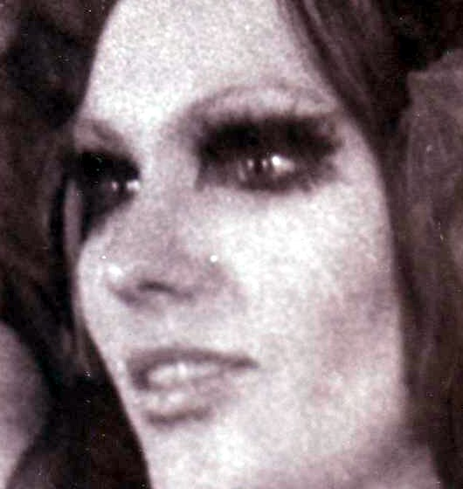
THE EYES HAVE IT!

Wow! Me and Mahler in the same sentence!

‘The Erotic Worlds of Frank Thorne’ was published by Eros Comix in June 1991. It features Frank in all his linguistic glory and you can feel the excitement as he traces the entire history of the Sonja shows. It’s filled with pictures of all of the various Sonjas and includes Frank’s own rendition of the multi-Sonja show that we performed at Seuling’s ComicArt con in Philadelphia in July 1977. I believe that comic may be hard to find but with a little luck, you can get a copy if you search carefully.

Frank also did an interview that just came out in the Jan. 2007 issue of the Comics Journal #280. It’s 40+ pages done in his distinctive style and art, tracking his life and artistic creations (and it’s not for the faint-hearted in some places.)

Anyway, back at Lily Langtry’s, Frank joined singer Kurt Gresham on the small stage as they talked about the theme song, which had been written by Mike & Sal Caputo.

Then Frank began to summon Sonja with that incredible impromptu act that he does so well. We arranged it that I would wait at the front of the club behind the audience and, once summoned, I would slowly approach the stage.

Frank wrote of my entrance: “A purple absence of sound enveloped the darkened room. A glint of light caught the eye…the parcel of light bore with it another hint of things to come. The star in the inverted black bowl of my ignoble career had begun to shine. Another star, and another. A small constellation took shape…reflecting the disks that made up Red Sonja’s iron bikini…for the first time I beheld my creation come to life.”

WOW! Frank Thorne rules!

Frank interviewed Red Sonja and I answered in my interpretation of Sonja using my humor and a slightly accented voice. I don’t remember what we said but the crowd loved every word and enjoyed Kurt’s rendition of the song as well.

Afterwards we posed for pictures and some time later, I would be given a couple of the 45 rpm records of the song (45 rpm records? Kids: ask your folks…second thought…your grandparents about this…), which included pictures of Frank and me on the back of the sleeve. While looking at this unusual collectible, I had a feeling that my adventures with Frank Thorne and Red Sonja were just beginning.

Indeed, shortly after the appearance at Lily’s Frank called me. He was even more excited than usual as he relayed the news, “Angie! There’s gonna be a SonjaCon!!”

It seems that Bob, Robert and the DVCA had done it again and organized a convention based on a single comic book character. SonjaCon was to be held at the Travelodge just off the Jersey Turnpike in Mt. Laurel that November.

Marvel would be represented there with Roy Thomas, Dick Giordano and Frank, of course, appearing and there would be all the trappings of any good con: dealer’s rooms, panels, etc. However, SonjaCon was a different kind of con and to this end there was to be a Red Sonja Look-Alike Contest.

Frank enthusiastically told everyone about SonjaCon, using the media, Marvel Comics and other fans, which resulted in a large number of fans and look-alikes eager to attend this new convention.

If you loved Red Sonja than SonjaCon was a dream come true. The place was alive with fantastic women wearing variations of that famous chain mail bikini. And it was there that I would meet a most unique group of fans—those glorious ladies who would join me in the fun of portraying our beloved red-haired barbarienne.

It was at the Look-alike contest that I met my fellow contestants: Diane DeKelb, Wendy Snow, Linda Behrle and Wendy Pini. Just as each of us wore our own homemade version of Red Sonja, we also brought into the spotlight a specific insight into this intriguing character.

Diane DeKelb and Wendy Snow each wore a silver sequin variation of Sonja’s costume and a cape. Wendy surprised everyone with her ingenious re-invention of Sonja’s armor by creating a costume that combined the familiar shoulder yoke with an original one piece design from her own artist’s mind and hands.

Wendy Snow told me this: “I was invited to participate at the Boston Globe Book Fair by the Sunday Funnies monthly comic con. I dressed as Sonja. I was told by the Boston Police female officer covering the event to “get dressed”. Apparently the old Blue Blood ladies had complained. This was in 1976-1977, remember? I had promised a couple of guys a photo op with me so I didn’t rush to change. The guys got their photos, then the officer nearly escorted me to the ladies’ room, to see that I’d changed into “civilian clothes.” Thus, I was Banned in Boston. Sonja had “MADE IT!”

I had upgraded my own Sonja for the Lily Langtry’s event back in September by sewing the sequins down so that they didn’t flap around, creating a better yoke and painting them a matte silver while my boots and gloves were recreated to match Frank’s designs as well.

Linda Behrle had also made her outfit from metal, taken in part from the fender of her old car! She spoke of her first meeting with Frank: “I worked at a store in the Livingston Mall and I was behind the cash register on the platform when a bearded bespectacled quasi-crazed man ran in and went down on one knee and, with a glazed look in his eyes (from my perception), he croaked out ‘Sonja’! I found out that my then-neighbor John Palmer—a comic book aficionado—had met Frank that day at a comic book show in the mall and told him that I’d modeled Red Sonja that year at a Star Trek Costume con and he told Frank where I worked.

Frank said later that he thought he was seeing ‘Sonja Incarnate’ when he saw me on the platform backlit by showcase lighting (I bet he said that to all the girls!)”

Wendy Pini had crafted an elegant and realistic recreation of the costume. Her husband, Richard remembers, “She did all the cutting and sewing of the ‘undergarment’ if that’s what I can be called—the fabric and leather foundation for the metal disks. Then I spent some time drilling the tiny holes so they could be stitched to the bikini top and bottom—I remember busting drill bit after drill bit doing that because the steel was tough and the bits were only about 1/32 of an inch wide.

The shoulder guards/collar was more of a challenge. Wendy wanted actual metal so the solution I came up with was to first build an armature from aluminum wire thick enough to hold its shape but still be flexible. In essence, the guard (as Frank drew it) was woven from pieces of wire. Then the entire thing was wound about with metal adhesive tape, the kind used on furnaces, to cover all the joints where wires were twisted together. THEN all of that was covered with liquid solder to make it all look like a solid, forged piece of work.

Once the shoulder guards were completed the bikini top was attached to that with leather thongs so that the shoulders would bear much of the weight of the metal bra. The loincloth was also covered with steel disks so it weighed some too—the entire costume weighed probably 10 pounds. I found a couple of steel rings at a hardware store so the the front and back loincloth parts could be attached to those at the hips. There was always a fear that a leather strap would give way and the bottom would fall off in the middle of a show—very embarrassing!

Wendy crafted the boots from the ground up, as I recall. She might have used ‘real’ boots as a foundation. I built the sword from an old harpoon I found at an antique store. Took the blade from the harpoon and added the hilt and the pommel (which was actually a doorknob!). Wendy also used four different wigs, all added together into one mane, to get the wild look that Frank drew.”

I love the fact that Richard combined a harpoon blade AND a doorknob for her sword—now that’s costuming!

There was a variety of hair styles among us as well. Both Wendy Pini and I wore wigs while Diane wore her own long red hair. Wendy Snow kept her blonde locks and Linda Berhle recounted this about her own Sonja hair: “I thought my hair would suffice for the character and found that the curlers that I had chosen had created a sort of curly red volcano of my own very limp hair. I had driven all of the way to the contest in the curlers and they had set very well. There wasn’t enough time to recurl or straighten things so my picture with Wendy and you [Angelique] makes me look like I was doing the ‘big hair’ version of Sonja to say the least… it’s also a good thing for me that the picture that survives is not in color—I had never tried coloring my hair red before and I was truly in Technicolor!”

My own red wig was very full and straight so I would use all kinds of setting gels and rollers to get that mass of wild curls that Sonja sported. Luckily, the wig could be set the day before and left to itself without me suffering with it.

Earlier I said that SonjaCon was a different kind of con and to that end our Look-Alike Contest was not run from the usual hotel ballroom but from the indoor pool area instead. Perhaps it was the ‘bikini’ aspect of our costumes that inspired that idea.

Whatever it was, we dutifully paraded around the rim of the pool and I believe it was Roy Thomas, who announced that Wendy Pini was the winner of the contest and deservedly so. In addition to her excellent costume recreation, Wendy’s passion and commitment to the character showed in every aspect of her presentation as Sonja.

After SonjaCon, there was a brief respite until Frank told us about a Sonja promotion and performance that was to be held at the Quaker Bridge Mall in New Jersey in February 1977. Frank had been so impressed by the success of the Look-Alike contest that he devised the concept of himself as a wizard calling forth the legendary Red Sonja from the depths of time and space so that he could learn more about her and her times. However, because his wizard was either so powerful or perhaps, not powerful enough, he ended up with more than one Sonja to contend with.

I believe that it was the love of Frank’s life, his wife, Marilyn, a lady as sweet and kind as her husband, who made a beautiful wizard’s costume complete with a pointy hat for him. This was a perfect costume for him, giving vent to the magnificent ham actor that is Frank Thorne. No one, in my opinion, outside of Great Britain has ever had the gift of classical gab like Frank.

I was very excited about going but then, at the last minute I had to do battle with an old enemy who chose that particular time to re-enter my life: asthma. Like most asthmatics, I’d had it as a child and thought I’d grown out of it as a teen but that Feb. of 1977, it sucker punched me from out of nowhere. I was heartbroken that I was in no condition to travel to the NJ Mall, let alone perform as Sonja.

Luckily, Linda and her friend, actor & writer David Meade, along with Wendy and Richard Pini, were able to join Frank, resplendent in his new Wizard outfit to put on the very first of the Red Sonja & the Wizard shows.

After some photo-ops and other promotions at the mall, they headed for the mall’s nightclub, called Duke’s, which was filled with a large, rowdy crowd of Princeton undergrads who had no idea of the show they were about to witness.

Here, Frank began his new found career of capturing the attention of an audience and casting his own kind of spell as he brought forth Linda in all of her Sonja-esque glory. Knowing what a knockout she is, I imagine that she cast quite a spell of her own over the crowd.

During her performance, she called out, “Hark then, dogs! Is there any of you man enough to challenge Red Sonja?”

To which, David Meade stepped forth and answered, “I, Mikal of Athos, challenge Red Sonja!” and they went at it with a fury and level of realism that was a bit more real than anyone expected.

Linda remembered this—“David Meade and I had a sword fight in the mall as a publicity teaser and I was using a much heavier sword than I was familiar with. I swung and missed and swung and connected…with his head! Fortunately he had a hard head and the sword only grazed him. After that near miss, I worked much harder to strengthen my arms so I didn’t do major damage the next time.”

I’m sure that David was glad to hear that! It seems he was always taking a beating from Sonja and the audience but then the men in our group usually didn’t fare very well. Except for the Wizard, of course.

Linda and David continued their fight until Mikal was bested. As he lay on the floor, helpless under her boot with her sword tip at his throat, Sonja cried out, “What shall I do with him?”, to which the excited crown answered, “Cut it off!”

Luckily for David the Wizard was able to dazzle this blood-thirsty mob with his spells and divert their attention to the next Sonja as she answered his incantations for her to appear.

Here again, Frank explains—“Wendy stalked to my side, and we did some dialogue. Then it happened. At SonjaCon Wendy was doing a beauty contest. Here she became Red Sonja. Alone in the spotlight she did a chilling, throaty monologue that segued into a frenzied dance ending with her sword balanced on her bosom.”

Richard had prepared a tape of the music that complimented Wendy’s performance which entranced the audience and when it came to the crescendo, “Duke’s exploded with a standing ovation.”

After the Quaker Bridge appearance, there were a couple of cons in May: A Creation Con in New York where Frank appeared as himself, then a comic con in Boston where he was joined by the local Sonja for the show, Wendy Snow—the lady of the golden hair and sexy one-piece chain mail outfit.

Then there was the Big Show. Months earlier, Phil Seuling had invited Frank to be a guest at his ComicArt Con, which was held in Philadelphia that year (July 1977). All of the Sonjas were invited to perform as well in what was advertised as the biggest “Red Sonja & the Wizard Show” ever.

It was a whirlwind of almost non-stop events! For starters, Frank had been contacted by Larry Angelo, the host of a Philly news show called ‘Evening Magazine’ to do an interview in his studio, followed by live coverage of the show. I’d been invited to stay over at the Thorne’s home the night before the con. What a fun group of people! They made me feel very welcome.

The next morning, Friday, July 1st, Frank and I loaded up his VW and headed out to Seuling’s con. When we got there, we met up with Linda and David and eventually, Wendy Snow, Diane Dekelb and Diane’s sweetie, Walt Rittenhouse.

I was interested to see that Diane had decided to play Robert E. Howard’s original character, Red Sonya of Rogantino, with Walt as her nemesis, Retlaw the Mad Monk, which was a character that Frank created especially for her.

Frank’s friend, Nick Arroyo, became our own personal documenter as he snapped pictures of us in the hotel room as we became our beloved barbarienne and throughout the convention.

I still treasure the gorgeous shot he took of me standing by the window as Sonja as well as another of me playfully besting Walt’s Monk with my sword.

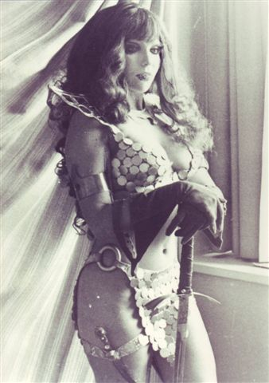

When we finally met up with Frank, we found there was a lot to do. First thing, Frank had a radio interview followed by Wendy Pini, Frank and myself doing another for the six o’clock news! Later, there was another radio interview for Frank while Wendy talked with another news team in the dealer’s room. Then at 8:30 pm, all of us met the press—Sonja-style! And on and on it went until later that night when we all managed to drag ourselves to Frank’s room to watch the TV coverage. It was the perfect ending to the perfect day.

The next morning, we were greeted by several news articles about us as well as a terrific picture of Wendy, Frank and me on the cover of The Philadelphia Inquirer.

By the way, Mark Evanier wrote an article about Phil Seuling and Wendy Pini’s appearance on the Philadelphia-based TV show ‘The Mike Douglas Show’. It’s a nice tribute to Phil and has a great shot of him and Wendy in all her Sonja finery. You can read it on Mark’s website at www.povonline.com/notes/NOTES 123104.htm.

Richard Pini also added this memory, “From what Wendy says, being in the green room backstage was a hoot…and that when General Westmoreland, another guest on the show, saw her he commented, ‘I didn’t know we were at war!’ When she walked out at the end of the comics segment, apparently Mike Douglas was not at all happy, as he was a bit of a prude.”

Maybe he liked his comic heroes in unitards?

We spend this day much as the day before and along the way, we picked up another Sonja. Gita Norby was a tall, pretty girl with an infectious smile. She wore her Sonja outfit well except for one thing, her hair was a dark brown bob above her shoulders. Nevertheless, we kept her with us because we were equal opportunity barbariennes and that’s how we rolled.

That afternoon there was an unrehearsed pre-show that we did well before the “Red Sonja & the Wizard Show” as a sort of introduction of us and a photo-op for the fans.

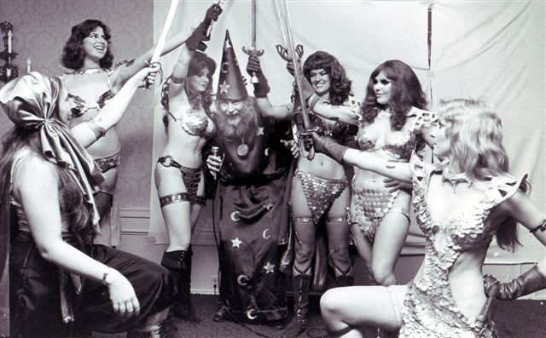
The Sonjas & The Wizard!

I remember standing at the back of the ballroom with the other Sonjas as the Wizard called for each of us to approach the stage. Then something really wonderful happened.

You see, being a Sonja means you’re nobody’s lapdog to be called forth like some doxy and, as a joke, we let the Wizard know that we were not pleased by his presumptuousness. Each Sonja had her own little jibe which she delivered to the offending Wizard in her own way as she approached the stage. I remember watching the new-found Gita standing on stage speaking to the audience and then she kneeled before the Wizard and said, “Please, oh great Wizard, give me back my hair.” The audience loved the unexpected humor and I admired Gita’s ingenuity in making a good show from the lack of a red wig.

Suddenly I found myself panicking since I wasn’t sure what I would say when my turn came. I didn’t have the Hyborian speak down pat like the others but at the last moment, perhaps inspired by Gita’s quick thinking, a flash of inspiration saved me. So when I was called, I sauntered up the aisle and said in my best Mae West imitation, “This better be good, honey!” The audience roared with laughter!

Luckily for me that Mae West, a very funny writer and comedienne, had been my role-model for years. That’s how I came up with my rendition of Sonja for the main event. I went over some Mae West lines with Frank, who thought the concept was a hoot and thus my part was truly born! It was great to see that I really could be funny in front of a crowd.

The show itself is forever immortalized in The Savage Sword Of Conan #29, highlighted by Frank’s meticulous drawings of each Sonja’s turn on stage: from his opening where he invites the audience to witness his spell casting to “conjure the deaconess of hell from the antediluvian epoch…” (where does he get this stuff?) to Linda’s entrance, followed by mine, then Diane, then Wendy Snow and finally Wendy Pini.

Five Sonjas?

“I must have over-incanted!” the Wizard cried.

However, he was determined to find the real Sonja among the imposters and so the show began with Linda and David recreating their exciting sword fight with poor Mikal again on the floor, saved by the Wizard’s pleas to spare his life.

Then the Wizard called upon me to ask about a dishonorable king in Sonja’s past. I answered (again in Mae West style), “At one point, he cornered me and said, ‘Oh Sonja, I’m mad about your flamin’ hair, your enticin’ eyes, your ruby lips, your pearly teeth, your lush figure.”

“The cad!” the Wizard exclaimed, and then like a gossip hungry for more juicy details, “What next?”

“I asked him if he was makin’ a pass or takin’ inventory!”

After me, Diane’s Sonya of Rogatino came forth and as she spoke, Retlaw appeared and another fight was on as she and Walt fought sword against quarter-staff in a well-choreographed fight that ended in Retlaw’s defeat.

Wendy Snow was up next as the Wizard asked her about her variance with Sonja’s armor to which she responded that it was to protect her belly button! They continued on in this funny vein until it was time to summon the last Sonja.

Wendy Pini presented another enthralling performance like the one she’d created at the Quaker Bridge Mall back in February but somehow did it even better as the cheering audience attested to. The show ended with all of us ganging up on the Wizard demanding to know which of us was the one true Red Sonja.

He answered, “I have, in fact, conjured the aspects of Sonja: the Body, Humor, Spirit, Mind and Soul of the great Hyrkanian swordswoman! Each of you is a part of the unassembled total!”

To which we chased his butt off stage—and in the comic version, he escapes into his pointy little hat! Then Wendy Pini’s Sonja suggests that we “…join as one, at least in the alehouse and raise a tankard in memory of the old faker!”

It really was a magnificent show!

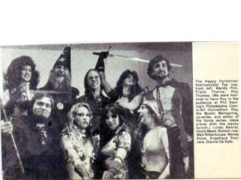
The Hyborian Players, including Roy Thomas!

After Phil’s con, Wendy and Richard Pini worked with Frank to develop the “Red Sonja and the Wizard Show” into a more professional looking production.

Richard’s talents with lights, sound and special effects and Wendy’s acting and dancing skills combined with Frank’s own gift for comedy and improv created a show that had a nice mixture of wit and flirtatious banter between wizard and swordswoman, leading up to her enthralling dance amid a flurry of lights and images created by Richard.

Audiences who saw the shows that were performed at a Boston Comic Con in October with a follow up in November at New York’s Creation Con were delighted with the results.

The July 1978 San Diego ComicCon hosted the last show because Wendy decided that she wanted to devote her full passion and energies into her newest and most demanding creation, Elfquest. Frank also had several projects that beckoned for his attention and so the shows ended.

Sadly, video was in its infancy at that time and as far as I know, there are no videos or film of those shows. Perhaps someone reading this may know otherwise?

The last time I wore my Sonja costume was at a New Jersey ComiCon in 1979. Frank and Linda Behrle were there performing his new comedy dealing with his latest creation, Danger Rangerette. Linda was, of course, Danger and Frank was Barf Beltless. I was there just for fun—because sometimes my idea of fun was walking around in a metal bikini with a sword…

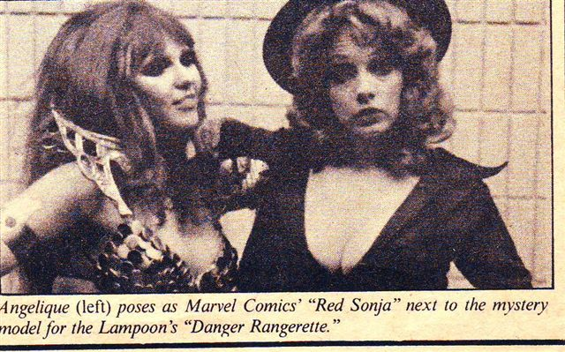
Angee & Linda Behrle

It occurs to me that Sonja always manages to find creative and fun-loving people to become her. I remember helping my friend Animal add dozens of mirrored disks all over a bikini she made when she decided to do Red Sonja for MarvelCon in March of 1975. Animal was the first one to recreate Sonja and today, Sonja lives on in the person of Wendy Potter, who performs her own version of the “Red Sonja and the Wizard show” in Virginia and Tennessee for a new generation of fans.

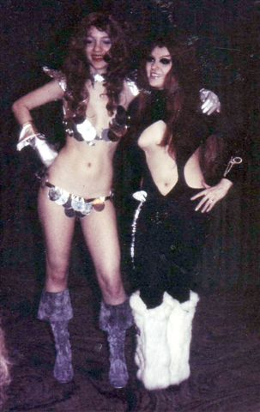
Angee’s friend Animal (as Red Sonja) & Angee (as Satana)

If you’re lucky enough to catch a performance by Wendy and company, you’ll see that Red Sonja is well served by this latest incarnation of the barbarienne. By the way, I believe that we have Richard Pini to thank for the coining of the word ‘Barbarienne’. He recently wrote this to me: “You know, I have the sneaking suspicion that I may have coined that word “barbarienne” around 1975. At least, doing a Google search of the word doesn’t reveal anything older than a couple of years. EQ-Wendy did a portfolio back then of 4 different pre-Elfquest warrior women that Warp published, and I called it “The Barbariennes” I’d be surprised if I actually invented the world but so far I haven’t found an earlier reference.”

Ha! Richard used the EQ-Wendy above (for Elfquest Wendy) because there are so many Wendys (Pini, Snow, Potter) in this area that we—Richard, Frank Thorne & myself—have all taken to using some kind of quick shorthand to identify which Wendy we’re talking about!

Now remember the part in the Big Show, when the Wizard said that the five Sonjas were aspects of the one true Red Sonja? Well, in that vein, I’d like to finish this piece with an update of that idea with these embodiments:

Animal X: the panache of the very first Sonja (talk about flash!)

Linda Behrle: the body of Sonja (‘nuff said!)

Wendy Snow: the individuality of Sonja (a one-piece suit and blonde
hair, now that’s individuality!)

Diane DeKelb: the literary Sonja (a writer herself who represented
Robert E. Howard’s original 15th century Sonya)

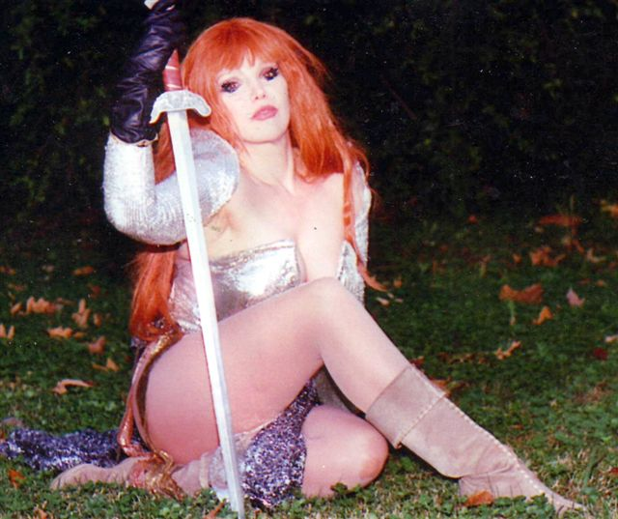
Angelique Trouvere: the wit and zest for life of Sonja (Frank Thorne
contributed that one--Thanks Frank!)

Wendy Pini: the indomitable spirit of Sonja

Gita Norby: the resourcefulness of Sonja

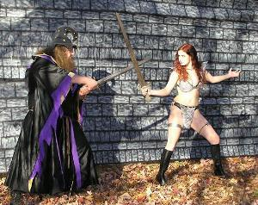
Wendy Potter: the continuing legend of Sonja. Wizard played by her brother Dan!

RED SONJA STILL ROCKS! (and always will)

In closing, I want to say that my costumes gave me access to a world of fascinating and creative people. I’ve had the honor of being the subject for such noted artists as Sergio Aragones, Neal Adams, Ernie Chan, Frank Kelly Freas, Marcus Boas, Clyde Caldwell and Frank Thorne among others.

I’m grateful for their friendships as well as the many writers, artists, editors, entrepreneurs, fans, costumers, actors, publishers, photographers, comic techs, lightshow techs, webmasters and lights & sound magicians who populate my life and memories.

All of you are a wonderful, bizarre and fun part of my life and I wouldn’t want it any other way. I’m still in awe at what you do.

Here’s one last story that illustrates that point beautifully: It goes back to Phil Seuling’s con in 1976. When I opened the program book, I found a series of old drawings that were captioned with comic con humor. The last drawing was of a 16th century man in all of his 16th century finery who had an incredulous look on his face as he said, “If you think my costume is something to see, wait till you see Angelique’s!!” I was totally floored by this unsolicited compliment. That was the great and kind Phil Seuling—a true super-hero!

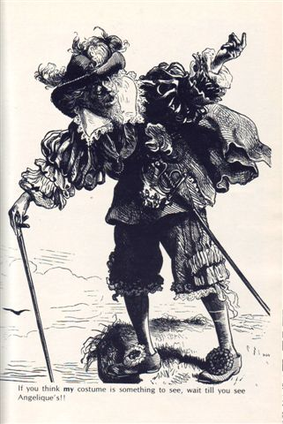

Thank you, Phil and company, for that sweet gesture. It was inspirational and I still treasure it.

I’d also like to thank everyone who contributed to this including: Tony Isabella, Kris Curling, Frank Thorne, Richard Pini, Linda Behrle, Wendy Snow, all of the Sonjas and everyone else who helped jog my memories and especially to you, Richard Arndt, for your patience and good humor. I promise, upon your death, to nominate you for sainthood!

And in case you didn’t notice, I had a ball doing this interview and I hope my ramblings have answered some questions and engendered others. To that end, I’d like to invite the readers to please send me your comments, questions, etc to costumaker@hotmail.com. I’d love to hear from you!

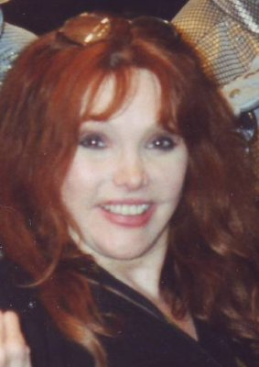
Pictures Of Angelique Today & Yesterday!

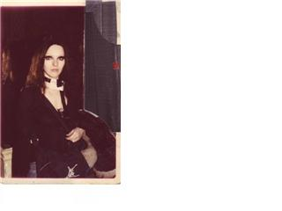

RA: Thanks so much, Angee! This was a blast!
--
This interview is copyright 2007 Richard J. Arndt.
© 2007 R. Arndt.

Do not reproduce or mirror this interview without prior written permission. Mainly, I’m worried about old versions floating around growing stale, so I want to keep track of where they are. Plus, please give credit where credit is due. If you want to post it or use it in some fashion, then feel free to contact me at rarndt39@hotmail.com.

Not for use or reproduction in any publication or media that is for sale, including but not limited to websites that are ad supported.

This interview may contain errors, omissions, or inaccurate material. It is provided as-is, without any express or implied warranties. Use it at your own risk. Although effort is made to keep all the material presented here accurate, the contributors and maintainer of this interview will not be held responsible for any damage -- direct or indirect -- which may result from inaccuracies.

Publications, titles of publications and characters appearing therein are ©, ® and/or ™ of their respective publishers, authors or creators.

